- Cài đặt NodeJS: nodejs.org & git-scm.com

- [Ebook NodeJS & SocketIO + Express Module (Web App)](http://khoapham.vn/KhoaPhamTraining/nodejs/snippet/Socket-IO-Realtime-Web-App-Development.pdf)

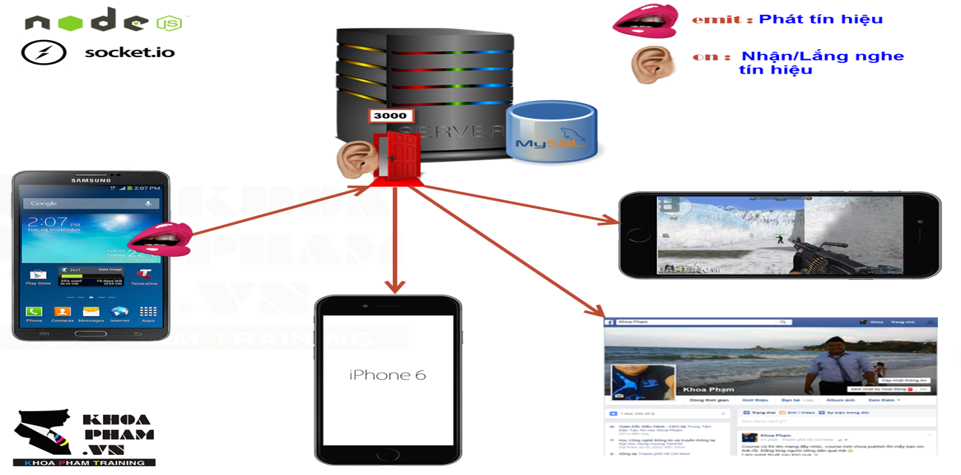

|  |  |
| --- | --- |
| https://khoapham.vn/KhoaPhamTraining/nodejs/snippet/nodejs.png | **Lập trình NodeJS cơ bản** |

var n = 5;

var x = 2;

-----------------------------------

if(n>x)

console.log(n + " lon hon " + x);

else

console.log(n + " nho hon " + x);

-----------------------------------

for(var i=1; i<=10; i++){

console.log("Dong so " + i);

}

-----------------------------------

var x=0;

while(x<=5){

console.log("Dong so " + x);

x++;

}

-----------------------------------

var mang = [];

mang.push("Teo Em");

mang.push("Teo Anh");

mang.push("Teo Chi");

console.log(mang.length);

console.log(mang[1]);

-----------------------------------

var buffer = new Buffer("Khoa Pham", "utf-8");

console.log(buffer);

console.log(buffer.toString());

console.log(buffer.toJSON());

-----------------------------------

var fs = require("fs");

var noidung = fs.readFileSync(__dirname + "/acquy.png");

console.log(noidung);

console.log(noidung.toString());

console.log(noidung.toJSON());

|  |  |
| --- | --- |
| https://khoapham.vn/KhoaPhamTraining/nodejs/snippet/nodejs.png | **Cấu hình file package.json** |

{

"name": "KhoaPham",

"version": "0.0.1",

"private": "true",

"dependencies": {

"express": "*",

"socket.io": "*",

"socketio-file-upload": "^0.4.4"

}

}

|  |  |
| --- | --- |
| https://khoapham.vn/KhoaPhamTraining/nodejs/snippet/nodejs.png | **Cấu hình Express** |

var express = require("express");

var app = express();

var server = require("http").createServer(app);

var io = require("socket.io").listen(server);

var fs = require("fs");

server.listen(process.env.PORT || 3000);

app.get("/", function(req, res){

res.sendFile(__dirname + "/index.html");

});

|  |  |
| --- | --- |
| https://khoapham.vn/KhoaPhamTraining/nodejs/snippet/nodejs.png | **Cấu hình đường dẫn thư mục trong Express** |

app.use("/asset", express.static(__dirname + "/layout"));

|  |  |
| --- | --- |
| https://khoapham.vn/KhoaPhamTraining/nodejs/snippet/nodejs.png | **NodeJS kết nối MySQL** |

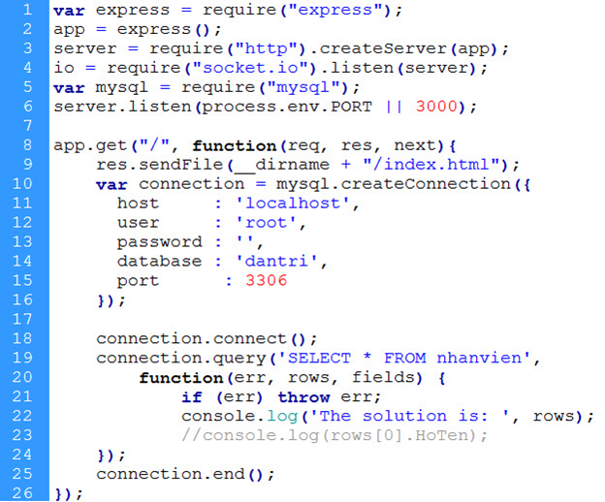

|  |  |
| --- | --- |
| https://khoapham.vn/KhoaPhamTraining/nodejs/snippet/nodejs.png | **Deply với Heroku** |

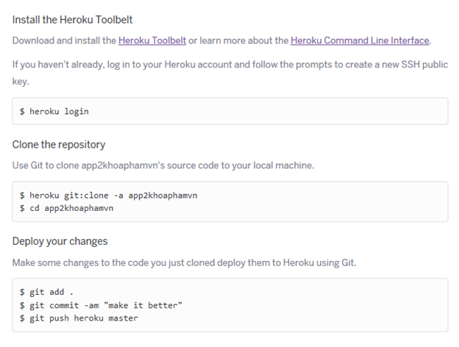

|  |  |
| --- | --- |
| https://khoapham.vn/KhoaPhamTraining/nodejs/snippet/nodejs.png | **SOCKET IO: Phía SERVER NODEJS** |

io.sockets.on('connection', function (socket) {

console.log("Co nguoi connect ne");

io.sockets.emit('serverguitinnhan', { noidung: "okbaby" });

socket.on('servernhantinnhan', function (data) {

// emit toi tat ca moi nguoi

io.sockets.emit('serverguitinnhan', { noidung: data });

// emit tới máy nguoi vừa gửi

socket.emit('serverguitinnhan', { noidung: data });

});

});

|  |  |
| --- | --- |
| https://khoapham.vn/KhoaPhamTraining/nodejs/snippet/nodejs.png | **SOCKET IO: Phía client WEB HTML** |

src="http://code.jquery.com/jquery-2.1.4.min.js"

src="/socket.io/socket.io.js"

$(document).ready(function(){

var socket = io.connect("http://localhost:3000/");

socket.emit("new user", "khoapham.vn");

socket.emit("new user", $username.val(), function(data){

if(data){

}else{

}

});

socket.on("server-gui-ve", function(data){

//io.sockets.emit("new message",{msg:data});

alert(data);

})

socket.on("disconnect", function(data){

if(!socket.username) return;

else

usernames.splice(usernames.indexOf(socket.username), 1);

});

});